Dis-Asia-China-Mirror-Liaoning-Jade

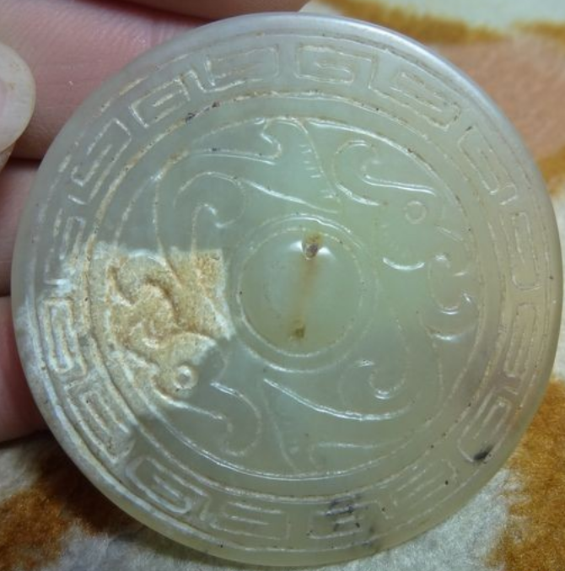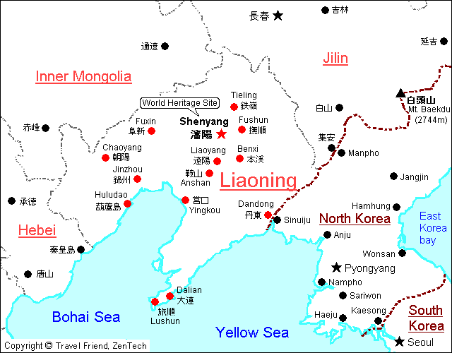

Mongolian Shaman’s Phoenix Mirror of Heavenly Ascent, Liaoning Province, Serpentine Jade, 2 Phoenixes within a stylized cloud motif symbolizing eternity, ca. 14th century. Size: 50mm. dia. x 5 mm. thickness.

Formal Label: Mongolian Shaman’s Phoenix Mirror of Heavenly Ascent, Liaoning Province, Serpentine Jade, ca. before the Ming Empire took control of Liaoning in 1371. Size: 50mm. dia. x 5 mm. thickness.

Accession Number: DS752/NK8440

Date or Time Horizon: ca. 14th century. Size: 50mm. dia. x 5 mm. thickness.

Geographical Area: Liaoning Province, Mongolia

Cultural Affiliation: Mongolian

Medium: Serpentine Jade

Dimensions: Dia. 50 mm. dia. x Thickness 5 mm.

Weight:

Provenance: Originally this was affixed to a Mongolian shaman’s cape.

**Condition: Museum grade**

**Discussion:** This mirror is carved from serpentine jade from **Liaoning** 遼寧 , “Laio River made peaceful,” named for the Liao River that flows through this northeast province of the People's Republic of China. Based on its iconography, it is of Mongolian manufacture and was carved before the Ming Empire took control of Liaoning in 1371, just three years after the expulsion of the Mongols from Beijing. (Dardess 2012: 18). This mirror was probably attached to a Mongolian's shaman’s cape traditionally adorned with many mirrors to literally “reflect” the shaman’s heavenly ascent to the upper-world of the spirits, and, with this mirror, the shaman was helped by the two carved Phoenixes that “f ly” within a stylized cloud motif symbolizing eternity.

Mongolian shamanism, Tengerism or Böö mörgöl (Бөө мөргөл), is devoted to the worship of the *tngri* (gods) and the highest *Tenger* or *Qormusta Tengri,* is Heaven(Balzer 2000). Generally, 99 *tngri* are worshipped, butsome liturgical texts add another 33 that are invoked only by the highest shamans for special occasions. Chief among the *tngri* are Qormusata Tngri and (Khan) Möngke Tngri, the latter named after Yesükhei (d. 1171)the father of Genghis Khan (1162 – August 18, 1227) and the main embodiment of the *Tenger*. One sect has been syncretized with Buddhism and is known as Yellow Shamanism, since its members wear yellow hats during services, while the sect not influenced by Buddhism is called Black Shamanism.

**References:**

Balzer, Marjorie Mandelstam. 2010. Religion and Politics in Russia: A Reader. Armonk, N.Y.: M.E. Sharpe.

Dardess. John W. 2012. Ming China, 1368-1644: A Concise History of a Resilient Empire. New York: Rowman and Littlefield.

Walther Heissig. *The Religions of Mongolia*. London: Routledge, 2000.